CMPT 371 Assignment 3 Wireshark Lab Zhixin Huang 301326521

1. IP address: 192.168.0.18

TCP port: 1191

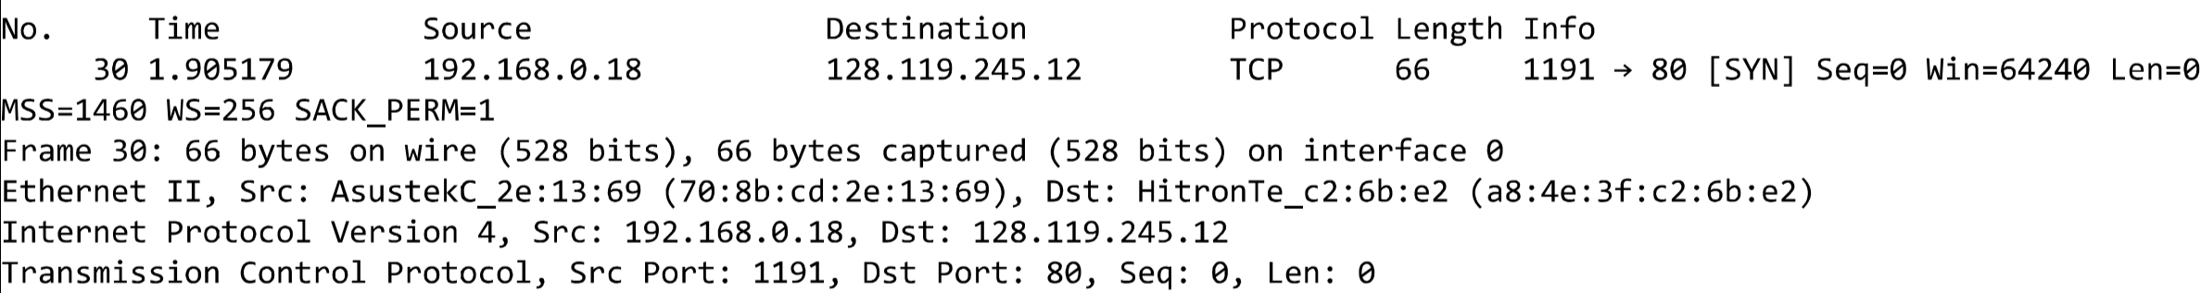

1. The sequence number of the SYNACK segment is 0. The value of the Acknowledgement field in the SYNACK segment is 1. gaia.cs.umass.edu determine that value by adding one to the sequence number of the SYNACK segment. Acknowledgment and syn flags are set to 1 to identifies the segment as a SYNACK segment.

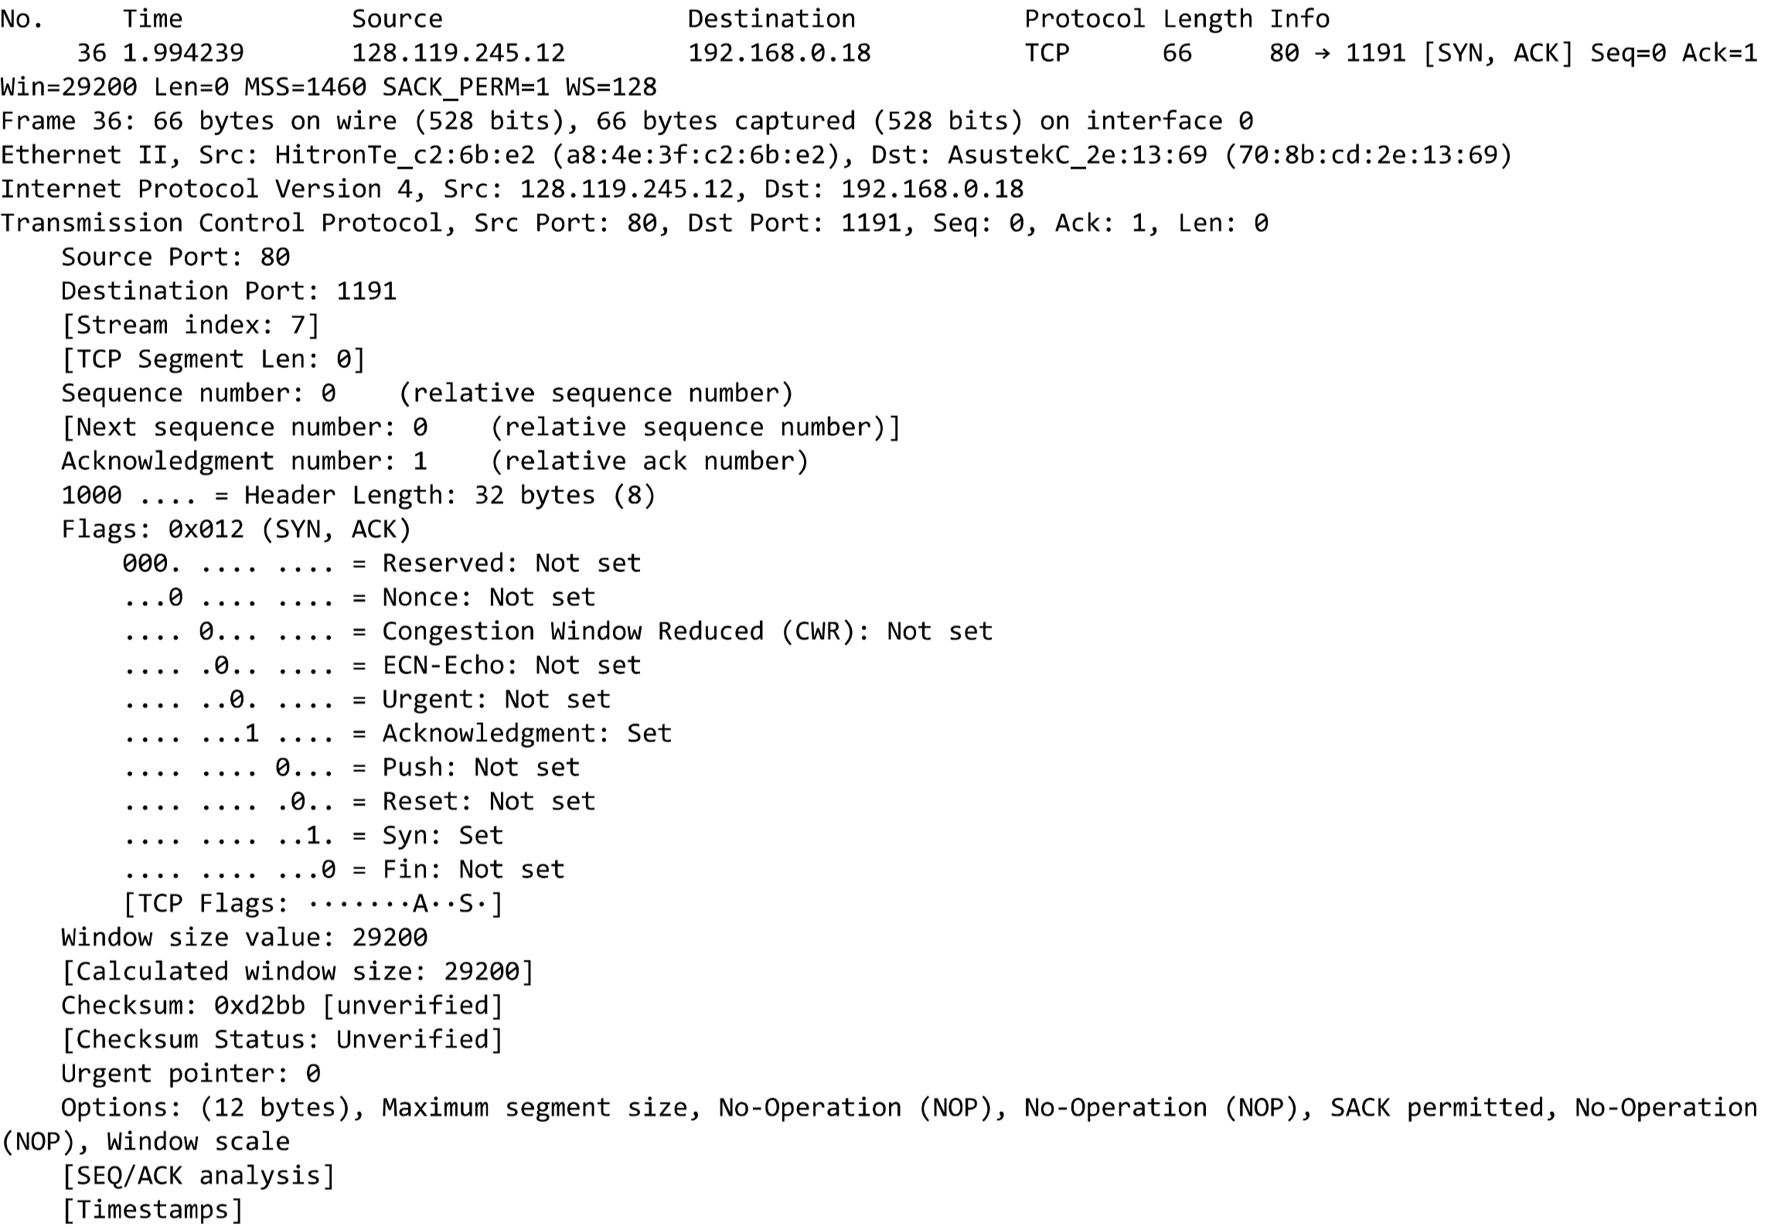

1. Length of the first is 710, others are1460.

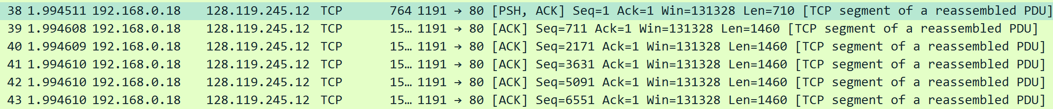

1. Yes, because there are some drops in the sequence number – time graph showing below.
2. Typically 1460, number 52 is acking number 40 an 41.

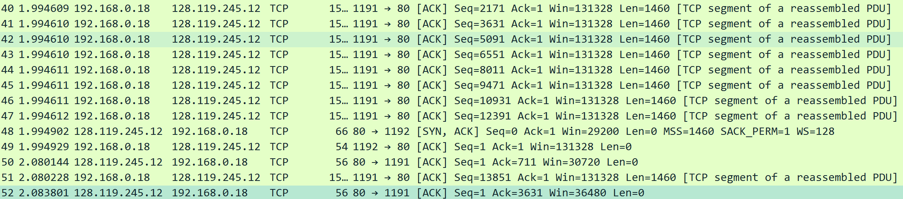

1. Slowstart begins at 0 second, ends at 0.1 second

